Name:_____________________

Year 12 ATAR Psychology

Investigation Handbook

Task 7: Sleep Hygiene Practical Investigation

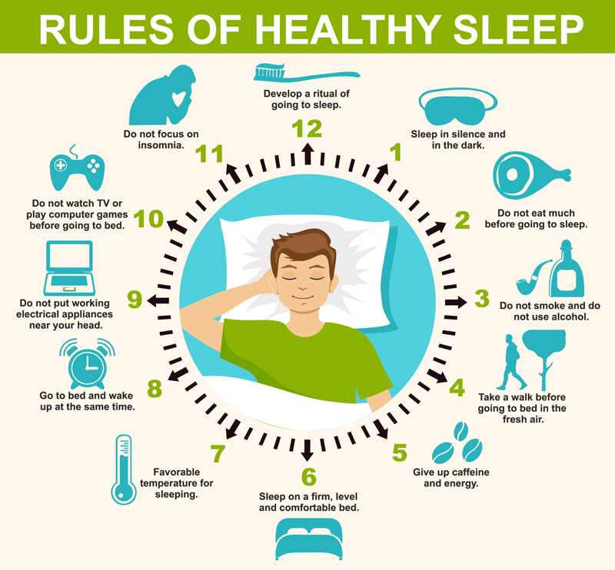

**PSYCHOLOGY ATAR – YEAR 12 2024**

**Unit 4**

**Task 7: Sleep Hygiene Investigation**

**Assessment type:** Science Inquiry (Practical)

**Weighting =** 12%

**Task Background**

Science inquiry is at the core of psychological knowledge and understanding. This task will develop your understanding of both sleep hygiene and Science inquiry.

Sleep hygiene is a behavioural and environmental practice developed in the late 1970s as a method to help people with mild to moderate [insomnia](https://en.wikipedia.org/wiki/Insomnia). Clinicians assess the sleep hygiene of people with insomnia and other conditions, such as [depression](https://en.wikipedia.org/wiki/Major_depressive_disorder), and offer recommendations based on the assessment.

Sleep hygiene recommendations include:

* establishing a regular sleep schedule
* using naps with care
* not exercising physically or mentally too close to bedtime
* limiting worry
* limiting exposure to light in the hours before sleep
* avoiding [alcohol](https://en.wikipedia.org/wiki/Alcohol_(drug)) as well as [nicotine](https://en.wikipedia.org/wiki/Nicotine), [caffeine](https://en.wikipedia.org/wiki/Caffeine), and other [stimulants](https://en.wikipedia.org/wiki/Stimulant) in the hours before bedtime
* and having a peaceful, comfortable and dark sleep environment.

However, as of 2021, the empirical evidence for the effectiveness of sleep hygiene is "limited and inconclusive" for the general populationand for the treatment of insomnia, despite being the oldest treatment for insomnia.

Assessing sleep hygiene is important to determine whether an individual has inadequate sleep hygiene disorder. The diagnostic assessment is usually conducted using a clinical interview, supplemented by self-report questionnairesand [sleep diaries](https://en.wikipedia.org/wiki/Sleep_diary). Sleep diaries are typically kept for one to two weeks, to record a representative sample data. There are also computerised assessments such as the Sleep-EVAL system, which can be employed in the diagnostic process.

Sleep deprivation occurs when an individual fails to get the amount of sleep that they need and can have mild to severe implications. Sleep deprivation can occur due to various lifestyle, work and environmental factors. Sleep disorders and other chronic medical conditions can also cause sleep deprivation.

**Task Requirements**

**PART A – 5% (51 marks):**

This practical investigation is based on the He et al. (2020) study which looked at the effect of restricting bedtime mobile phone use on sleep, arousal, mood and working memory. For 6 days, you will be testing the impact of restricting electronic device use before bed on sleep quality, mood, energy levels, motivation and attention. For 3 days (Monday-Wednesday) you will follow your normal bedtime routine, then for the same 3 days in the following week you will restrict the use of any devices 30 minutes before bed. Each morning, and throughout the day, you will answer a series of self-report questions to assess your sleep quality and cognitive functioning.

The measurement tool will be a self-assessment table that will be provided.

Your role:

* Familiarise yourself with He et al (2020)
* Participate in the data gathering activity by submitting a completed Self-Assessment Recording Table
* Complete the submission requirements for Part A
* Prepare yourself for the in-class component (Part B)

Submission Requirements (to be submitted at the conclusion of completing Part B):

* An abstract – provide an overview of the investigation, including the aim, main features of the method, summary of results and conclusion/s
* An introduction – provide information and research related to the topic for the investigation, including a directional hypothesis - this will be needed during your completion of Part B
* Method – describe the participants, materials and procedures so that the investigation can be replicated (standardised procedures)
* Results – represent data in a written summary, tables and graphs
* Discussion
  + Discuss the results of the investigation and how they relate to relevant psychological theories
  + Evaluate the design of the investigation and explain how the investigation could be improved
  + Discuss how ethical issues were addressed
  + Explain the relevance of the results to the population from which the sample was drawn, and to theory or other research.
  + State a conclusion that relates the results to the hypothesis or research question
* References – provide an alphabetical list of any references used in the report
* Appendix – attach your data sheet.

All participants in the investigation activity must provide informed consent.

**PART B – 7% (47 marks):**

Data from all participants will be collated and you will complete a written task (under test conditions) that contains questions allowing you to demonstrate your ability to process data and evaluate research, and your knowledge on the syllabus content related to the topic.

**Conditions**

Time for the task:

* Part A: 3 hours in class plus homework time to conduct planning, research and writing
* Part B: 50 minutes to complete an in-class validation under supervised conditions

**Marking key – Part A**

**Abstract**

|  |  |
| --- | --- |
| **Description** | **Marks** |
| **Aim** |  |
| Succinctly writes an aim | 2 |
| Provides a general aim | 1 |
| Not met | 0 |
| **Method** |  |
| Describes the method including:   * The participants * Materials used * How the task was administered | 1-3 |
| Not met | 0 |
| **Results** |  |
| * States the results of the research * Draws a relevant conclusion | 2 |
| * States the results of the research OR * Draws a relevant conclusion | 1 |
| Not met | 0 |
| **Sub-Total** | **7** |

**Introduction**

|  |  |
| --- | --- |
| **Description** | **Marks** |
| **Personality** |  |
| Provides a psychological definition of sleep hygiene | 1 |
| Not met | 0 |
| **Creation of healthy sleep environment** |  |
| Provides a detailed description of the circadian rhythm and provides relevant links to practices to create a healthy sleep environment and sleep-wake cycle and melatonin production.   * Provides detailed description of circadian rhythm, sleep-wake cycle and links to melatonin production. * Explains the relevance of electronics use to sleep hygiene * Links the relevance of the sleep hygiene practice to their own study. | 3 |
| * Provides detailed description of circadian rhythm. * Explains the relevance of electronics use to sleep hygiene | 2 |
| * Provides description of circadian rhythm, noting the use of electronics as a disruption. | 1 |
| Not met | 0 |
| **Research** |  |
| Provides a summary of relevant research relating to the investigation including a description of methods and results | 2 |
| Refers to some research without making links to the topic | 1 |
| Not met | 0 |
| **Hypothesis** |  |
| Hypothesis is directional | 1 - 4 |
| Not met | 0 |
| **Sub-Total** | **10** |

**Method**

|  |  |
| --- | --- |
| **Description** | **Marks** |
| **Selection** |  |
| Describes the selection process and participants in sufficient detail to be replicated (e.g. number, age, gender) | 3 |
| Describes the selection process or participants in sufficient detail to be replicated (e.g. number, age, gender) | 2 |
| Briefly describes the process and participants | 1 |
| Not met | 0 |
| **Materials** |  |
| Describes materials in sufficient detail to be replicated | 2 |
| Briefly describes materials | 1 |
| Not met | 0 |
| **Procedure** |  |
| Describes the procedure including:   * Describes task in sufficient detail to be replicated * Provides standardised procedures and instructions * Describes management of variables including explanation of uncontrolled variables * Addresses validity and reliability | 4 |
| Describes the procedure including:   * Describes task in sufficient detail to be replicated * Describes management of variables * Addresses validity and reliability | 3 |
| * Briefly describes how data will be collected * Describes management of variables including explanation of uncontrolled variables | 2 |
| Describes the procedure including one of the following:   * Briefly describes how data will be collected | 1 |
| Not met | 0 |
| **Sub-total** | **9** |

**Results**

|  |  |
| --- | --- |
| **Description** | **Marks** |
| **Tables** |  |
| Organises all relevant data logically in correctly labelled tables, including all of the following:   * Correctly organises the table * Correctly labels table, including units where appropriate * Includes relevant data | 3 |
| Organises all relevant data logically in correctly labelled tables, including two of the following:   * Correctly organises the table * Correctly labels table, including units where appropriate * Includes relevant data | 2 |
| Organises all relevant data logically in correctly labelled tables, including one of the following:   * Correctly organises the table * Correctly labels table, including units where appropriate * Includes relevant data | 1 |
| Not met | 0 |
| **Graphs** |  |
| Presents data in a graph. Completes all of the following:   * Correctly graphs data * Uses appropriate labelling * Uses appropriate titles | 3 |
| Presents data in a graph. Completes two of the following:   * Correctly graphs data * Uses appropriate labelling * Uses appropriate titles | 2 |
| Presents data in a graph. Completes one of the following:   * Correctly graphs data * Uses appropriate labelling * Uses appropriate titles | 1 |
| Not met | 0 |
| **Summary** |  |
| Provides an accurate and detailed description of the data | 2 |
| Briefly and accurately describes the data | 1 |
| Not met | 0 |
| **Sub-total** | **8** |

**Discussion**

|  |  |
| --- | --- |
| **Description** | **Marks** |
| **Results** |  |
| * Discusses the results of the investigation * Relates the results to the hypothesis * Explains how the results relate to other studies. | 4 |
| * Describes what happened in the investigation * Cites relevant psychological studies | 2 |
| Describes what happened in the investigation | 1 |
| Not met | 0 |
| **Design** |  |
| Evaluates the investigation design including all of the following:   * Explicitly explains how variables are controlled * Discusses any methodological flaws * Explains steps taken to ensure reliability and how it can be improved | 3 |
| Evaluates the investigation design including two of the following:   * Explicitly explains how variables are controlled * Discusses any methodological flaws   Explains steps taken to ensure reliability and how it can be improved | 2 |
| Evaluates the investigation design including one of the following:   * Explicitly explains how variables are controlled * Discusses any methodological flaws   Explains steps taken to ensure reliability and how it can be improved | 1 |
| Not met | 0 |
| **Ethics** |  |
| * Identifies ethical issues in the investigation * Describes how the ethical issues identified were addressed | 2 |
| Identifies ethical issues in the investigation | 1 |
| Not met | 0 |
| **Relevance** |  |
| Discusses relevance of results to the population from:   * The sample was drawn * The context of the sample (school students) | 2 |
| Suggests how the investigation might be of relevance to science or society | 1 |
| Not met | 0 |
| **Sub-total** | **11** |

**Conclusion**

|  |  |
| --- | --- |
| **Description** | **Marks** |
| Makes accurate conclusions that relate to the hypothesis or research question | 2 |
| Forms an accurate conclusion but does not relate it to the hypothesis or research question | 1 |
| Not met | 0 |
| **Sub-total** | **2** |

**References**

|  |  |
| --- | --- |
| **Description** | **Marks** |
| Reference list includes a range of relevant references in correct APA formatting   * Relevant references * Range of references * Listed alphabetically | 1-3 |
| Not met | 0 |
| **Sub-total** | **3** |

**Appendix**

|  |  |
| --- | --- |
| **Description** | **Marks** |
| Appends data sheet | 1 |
| Not met | 0 |
| **Sub-total** | **1** |
| **Total** | **51** |

**Applications of Psychology to Health – Sleep Hygiene Practical Investigation**

**Information letter**

Dear student,

As part of this unit in psychology, you will be examining the effect of restricting the use of devices before bedtime. You will be collecting self-report data on your own sleep quality, then sharing this information so that all individual responses from students can be collated and analysed.

To safeguard anonymity, students’ written responses will be identified by a code number and all individual student data will be shredded at the completion of the unit. Emails sent to the class teacher will be deleted.

Please ask me if you do not fully understand the information provided or if you would like further information. In understanding what is required of you as a participant in this investigation, you may choose to consent to participate fully in this investigation, in some part of this investigation or not at all. If you decide to participate, please read, complete and sign the attached consent form.

Your parent or guardian must also provide consent for your participation in this investigation. If they agree, please ask them to also sign the provided consent form.

Even if you have signed the consent form, you may withdraw from this investigation at any time. There will be no consequences if you do not want to participate, or if you initially agree to participate and later decide to withdraw. Your rights and responsibilities are detailed in the consent form.

**If participants are under 18:** Your parent/guardian must also provide consent for your participation in the Science inquiry activity. If they agree to your participation, please ask them to sign the provided consent form. No student/person is able to participate without a completed consent form.

**If participants are over 18 and capable of informed consent:** Please sign the consent form provided.

If you (or your parent/guardian) would like further information or clarification, please do not hesitate to speak with or email me.

Yours sincerely,

Mr Lane

Psychology Teacher

**Applications of Psychology to Health – Sleep Hygiene Practical Investigation**

**Consent form**

Participant’s name:

Investigation title: Sleep Hygiene

Teacher’s name: Mr Lane

I consent to participate in the research investigation named above. The nature of the research, including the procedures, has been explained to me, and is summarised on the information letter I have been given.

I give permission for the responsible teacher, named above, to use the outlined investigation procedures with me.

I understand that:

(a) I am free to withdraw from the investigation at any time. There will be no consequences if I decline to participate or if I initially agree to participate, but later decide to withdraw.

(b) The investigation is for the purpose of teaching and learning.

(c) The confidentiality of the information I provide will be safeguarded. Written responses will be identified only by a code number in order to ensure that responses are anonymous.

(d) There are no known adverse effects of participation in this investigation.

(e) I will maintain the confidentiality of other participants in this investigation.

**Please return this signed consent form to your teacher.**

**Signed:** . . . . . . . . . . . . . . . . . . . . . . . . . . . . . . . . **Date:** . . . . . . . . . . .

(student)

**Students may participate in this investigation only if a parent or guardian completes the following section.**

I consent to the participation of . . . . . . . . . . . . . . . . . . . . . . . . . . . . . . in the above research investigation.

**Signed:** . . . . . . . . . . . . . . . . . . . . . . . . . . . . . . . . **Date:** . . . . . . . . . . .

(parent/guardian)

**Self-Assessment Recording Tables**

Table 1: Snapshot of overall sleep quality and amount

|  |  |  |  |  |  |  |
| --- | --- | --- | --- | --- | --- | --- |
|  | **Normal Bedtime Routine** | | | **Restricting Device Use 30 Minutes Before Bed** | | |
| DAY 1 | DAY 2 | DAY 3 | DAY 1 | DAY 2 | DAY 3 |
| Number of Cumulative Hours Slept |  |  |  |  |  |  |
| Sleep Quality ( /10) |  |  |  |  |  |  |
| Device Used 30 Minutes Before Bed? (Yes/No) |  |  |  |  |  |  |
| Mean |  |  |  |  |  |  |

Table 2: Student self-report on cognitive functions throughout the day when conducting normal bedtime routine

|  |  |  |  |  |  |  |  |  |  |
| --- | --- | --- | --- | --- | --- | --- | --- | --- | --- |
| **Self-Report Rating ( /10)** | **MORNING (6am – 9am)** | | | **MIDDAY (12pm)** | | | **EVENING (4pm – 7pm)** | | |
| **DAY 1** | **DAY 2** | **DAY 3** | **DAY 1** | **DAY 2** | **DAY 3** | **DAY 1** | **DAY 2** | **DAY 3** |
| **Energy Levels** |  |  |  |  |  |  |  |  |  |
| **Motivation** |  |  |  |  |  |  |  |  |  |
| **Mood** |  |  |  |  |  |  |  |  |  |
| **Attention** |  |  |  |  |  |  |  |  |  |
| **Mean** |  |  |  |  |  |  |  |  |  |

Table 3: Student self-report on cognitive functions throughout the day when restricting device use 30 minutes before bed.

|  |  |  |  |  |  |  |  |  |  |
| --- | --- | --- | --- | --- | --- | --- | --- | --- | --- |
| **Self-Report Rating ( /10)** | **MORNING (6am – 9am)** | | | **MIDDAY (~12pm)** | | | **EVENING (4pm – 7pm)** | | |
| **DAY 1** | **DAY 2** | **DAY 3** | **DAY 1** | **DAY 2** | **DAY 3** | **DAY 1** | **DAY 2** | **DAY 3** |
| **Energy Levels** |  |  |  |  |  |  |  |  |  |
| **Motivation** |  |  |  |  |  |  |  |  |  |
| **Mood** |  |  |  |  |  |  |  |  |  |
| **Attention** |  |  |  |  |  |  |  |  |  |